Vocabulary N° 6
“Jack and the beanstalk”
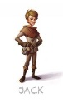

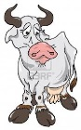
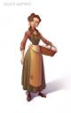
Jack and beanstalk is a British fairy tale. The story is about a young lad,
his mother and a cow
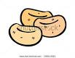
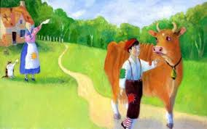
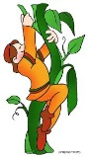
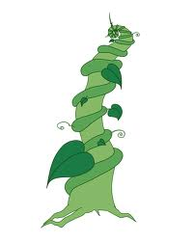
When the cow stopped giving milk, it was sold for three magic beans. Mother was angry and threw the beans to the ground.

A gigantic beanstalk grew overnight, Jack climbed it and found a
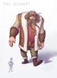
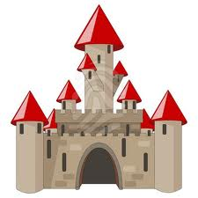
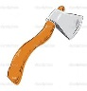
castle with a giant inside.

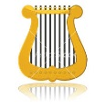
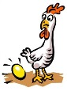
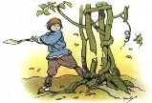
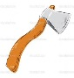
Jack stole from the castle a harp and a hen when the giant was asleep. The giant followed him down and Jack asked her mother for an ax Jack chopped the beanstalk killing the giant.

